Table S1 - Internal Standards used, Retention Time, LOD/LOQ and repeatability values for synthetic pesticides
 | ISTD | RT | LOD | LOQ | Repeatability
 |  |  | ng/g | ng/g | (RSD %)
Fungicides
Ametoctradin | a | 15.2 | 2.8 | 9.3 | 14.3
Azoxystrobin | a | 14.8 | 0.3 | 1.0 | 5.2
Boscalid | a | 15.0 | 2.7 | 8.9 | 14.8
Carbendazim | b | 9.8 | 0.3 | 1.0 | 4.6
Cyflufenamid | a | 16.9 | 1.8 | 6.1 | 4.9
Cyproconazole | c | 14.4 | 0.6 | 2.0 | 6.6
Cyprodinil | a | 15.9 | 7.9 | 26.4 | 15.1
Diéthofencarb | a | 14.6 | 0.2 | 0.6 | 6.4
Difenoconazole | c | 16.1 | 3.2 | 10.8 | 11.8
Dimethomorph* | a | 14.2 | 0.3 | 0.9 | 8.1
Fenbuconazole | c | 15.3 | 1.5 | 5.1 | 13.3
Fenhexamid | a | 15.0 | 4.1 | 13.5 | 8.2
Fludioxonil | d | 14.5 | 0.7 | 2.4 | 3.4
Fluopicolide | a | 15.1 | 0.7 | 2.4 | 8.4
Fluopyram | a | 15.2 | 0.3 | 1.0 | 9.4
Flusilazole | c | 15.2 | 1.8 | 5.9 | 13.3
Hexaconazole | c | 15.4 | 1.7 | 5.6 | 11.5
Imazalil | a | 13.2 | 7.5 | 24.9 | 20.7
Iprovalicarb* | a | 14.6 | 0.1 | 0.3 | 5.6
Mandipropamid | a | 14.9 | 0.3 | 0.9 | 4.1
Metalaxyl | a | 13.2 | 0.3 | 0.9 | 5.5
Metrafenone | a | 17.1 | 0.7 | 2.6 | 7.1
Prochloraz | a | 15.8 | 1.9 | 6.4 | 8.5
Pyraclostrobin | a | 16.5 | 0.2 | 0.7 | 4.5
Pyrimethanil | a | 14.4 | 5.3 | 17.6 | 10.6
Spiroxamine* | a | 13.7 | 1.2 | 4.1 | 19.5
Tebuconazole | c | 15.2 | 1.1 | 3.5 | 6.7
Thiophanate-methyl | a | 12.2 | 1.5 | 5.0 | 10.5
Triadimenol* | c | 14.1 | 1.0 | 3.0 | 5.0
Trifloxystrobin | a | 17.0 | 0.2 | 0.6 | 7.4
Zoxamide | a | 16.4 | 1.0 | 3.3 | 5.8
Insecticides / Acaricides
DMF (amitraz metabolite) |  | 11,4 | 3.1 | 10.4 | 12.2
Acetamiprid | a | 10.5 | 0.6 | 1.9 | 6.3
Buprofezin | a | 18.2 | 0.3 | 1.0 | 13.8
Chlorantraniliprole | a | 14.0 | 3.5 | 11.6 | 7.2
Clofentezine | a | 16.6 | 11.0 | 36.8 | 19.8
Clothianidin | a | 9.9 | 1.5 | 5.1 | 6.3
Coumaphos | a | 16.5 | 2.7 | 8.9 | 5.2
Cymiazol | a | 11.3 | 2.0 | 6.8 | 8.4
Dimethoate | a | 10.4 | 0.2 | 0.8 | 5.4
Fipronil | a | 15.9 | 1.3 | 4.2 | 6.7
Imidacloprid | a | 10.2 | 1.2 | 4.0 | 6.7
Malathion | a | 15.4 | 0.3 | 1.0 | 5.3
Methiocarb | a | 14.4 | 0.3 | 0.9 | 5.7
Methoxyfenozide | e | 15.2 | 2.4 | 8.2 | 11.4
Tebufenozide | e | 15.8 | 8.5 | 28.3 | 20.6
Thiacloprid | a | 11.3 | 1.7 | 5.8 | 4.6
Thiametoxam | a | 9.3 | 0.6 | 2.1 | 4.8
Thiodicarb | a | 12.4 | 0.2 | 0.6 | 5.5
Synergist
Piperonyl butoxid | a | 17.5 | 0.3 | 0.9 | 6.8
Herbicides
Atrazine | a | 13.1 | 1.3 | 4.5 | 7.2
Desethyl-atrazine | a | 10.2 | 1.9 | 6.4 | 13.8
Diuron | a | 13.2 | 0.5 | 1.6 | 6.0
Linuron | a | 14.5 | 3.9 | 13.0 | 11.3
Metolachlor | a | 15.6 | 0.3 | 1.0 | 6.1
Terbuthylazine | a | 14.4 | 1.6 | 5.3 | 10.9
Desethyl-terbuthylazine | a | 12.1 | 1.1 | 3.6 | 4.9
*: mixture of isomers
Internal standards: a, triphenylphosphate; b, carbendazim-d4; c, tebuconazole-d6, d, fludioxonil-13C2, e, tebufenozide-d9
LOD/LOQ: concentrations corresponding to S/N ratio of 3 and 10 respectively
Repeatability : mean of the relative standard deviation (RSD) of 3 replicates (9 samples)

Table S2 - Wave lengths used for the analysis of elements by ICP-AES (A) and Isotopes and mode used for the analysis of trace elements by ICP-MS (B)
A |  |  |  |  | B
Element | Wave length (nm) |  |  |  | Element |  |  | Isotope | Mode
Aluminium | 396.152 |  |  |  | Arsenic |  |  | 75As | He/He
Calcium | 422.673 |  |  |  | Cadmium |  |  | 114Cd | No gas
Copper | 327.395 |  |  |  | Cobalt |  |  | 59Co | He
Iron | 259.940 |  |  |  | Chromium |  |  | 52Cr | He
Sulfur | 181.972 |  |  |  | Molybdenum |  |  | 98Mo | No gas
Magnesium | 285.213 |  |  |  | Lead |  |  | 208Pb | No gas
Manganese | 259.372
Phosphorous | 213.618
Potassium | 766.491
Zinc | 213.857

Table S3 - Range, Mean and SD of pesticide residues quantified in the Vineyard location.
Values are mean of the 3 replicates in each hive (range ppb) and the mean of the two hives (mean ± SD)
* Detected or quantified in only one hive
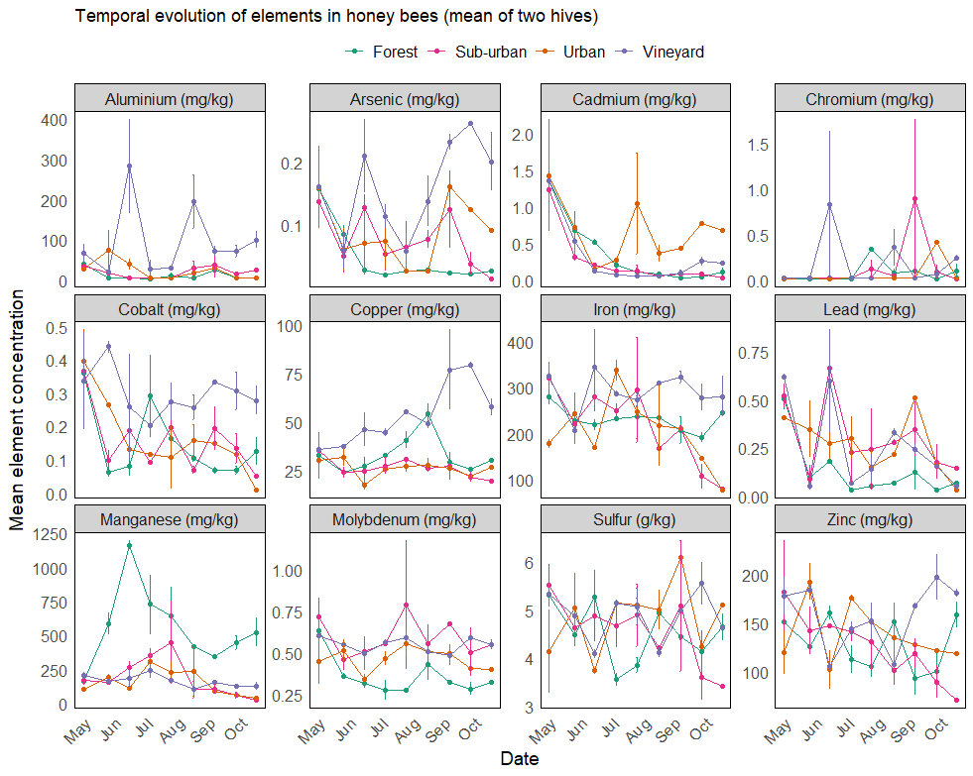
Figure S1 - Concentrations of trace elements (mg/kg) and sulfur (g/kg) quantified in honey bees sampled between May and October in contrasted locations. Values presented are mean ± SE of the two hives placed at each location (Forest, Sub-urban, Urban, Vineyard).

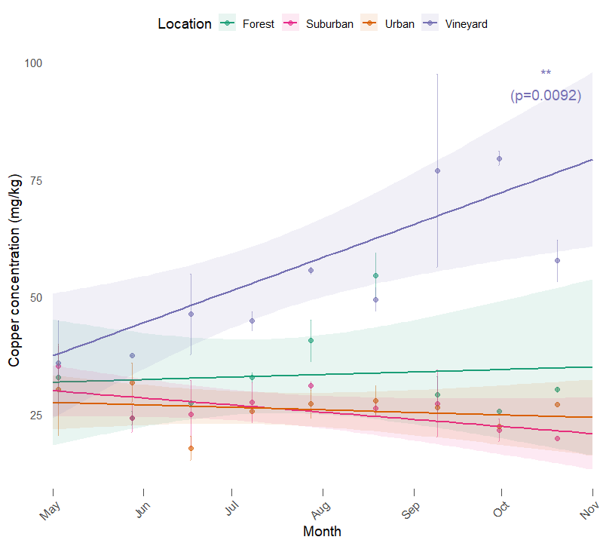
Figure S2 - Evolution of copper concentrations in honey bees by location. Dots are true sampling dates and fitted lines represent trends over the study period. The monthly bioaccumulation of copper was calculated through the estimation of slopes in each Location. Increasing concentrations of copper with time was revealed in Vineyards only (lm, estimate: 6.95 ± 1.95, p-value = 0.00918) whereas other locations did not exhibit any significant positive or negative relationship (p-value, Forest = 0.788, Sub-urban = 0.0986, Urban = 0.550).

